AWS S3 Hands-on Lab: Bucket, Versioning, Public Access, ACLs, Bucket Policy, and Validation
Lab Objective
By the end of this lab, you will learn how to:
- Create an S3 bucket
- Create folders
- Upload files
- Enable versioning
- Upload new versions
- Delete and restore objects
- Enable ACLs
- Make objects public using ACL
- Access objects from a web browser
- Disable ACLs
- Make objects public using Bucket Policy
- Block public access
- Validate Access Denied
- Understand the security differences between ACLs and Bucket Policies

Lab Architecture
Internet Browser
|
|
https://bucket.s3.amazonaws.com/file.txt
|
-----------------------------
| Amazon S3 |
|---------------------------|
| Bucket |
| ├── documents/ |
| ├── images/ |
| ├── backups/ |
| |
| Versioning Enabled |
| ACL Enabled/Disabled |
| Bucket Policy |
-----------------------------

Prerequisites
- AWS Account
- IAM User with S3 Full Access
- AWS Console Login

Exercise 1 - Create an S3 Bucket
Step 1
Open
AWS Console
Go to
Amazon S3
Click
Create Bucket
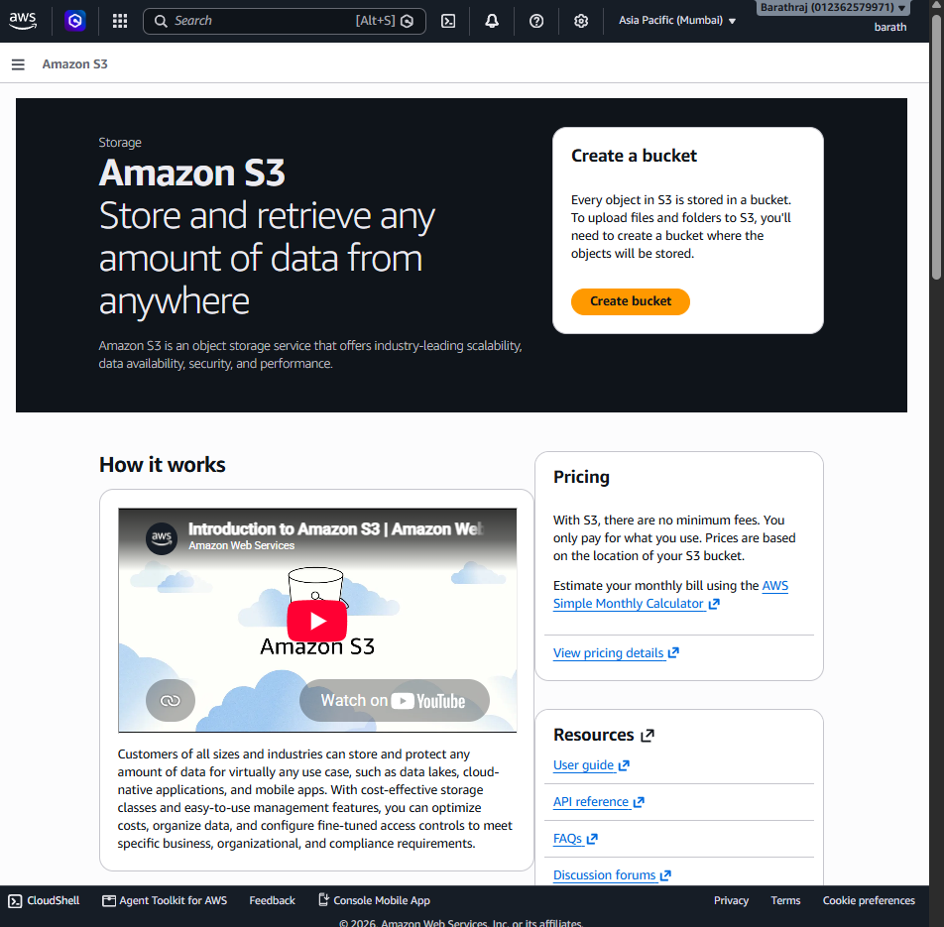

Bucket Name
Example
balaji-s3-lab-001
Must be globally unique.
Region
Asia Pacific (Mumbai)
or any region.

Object Ownership
Choose
ACLs disabled (Recommended)
(We will change later.)
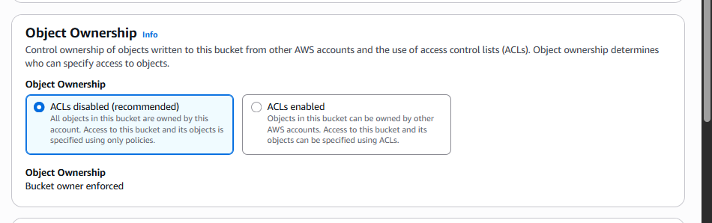

Block Public Access
Keep all boxes checked.
✔ Block all public access
Click
Create Bucket
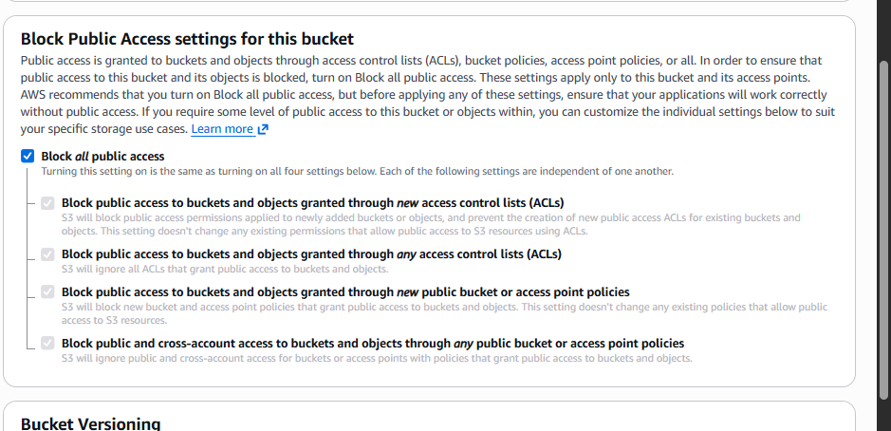

Validation
Bucket should appear.
studentname-s3-lab-001
Status
Created Successfully
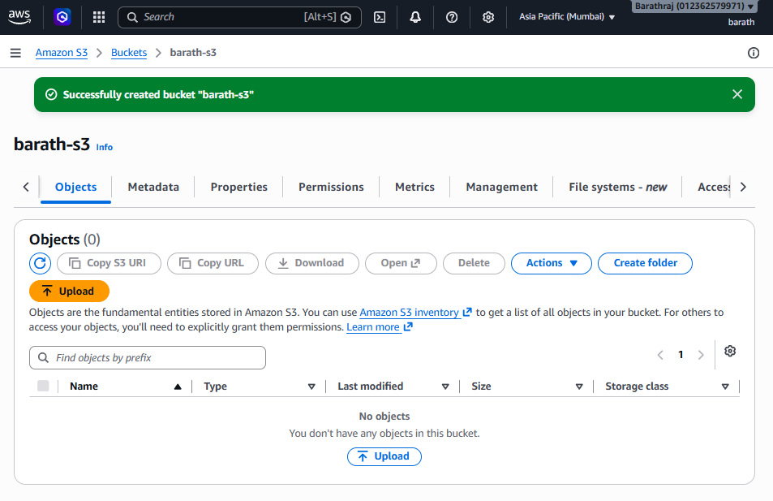

Exercise 2 - Create Folder Structure
Open bucket.
Click
Create Folder
Create
documents/
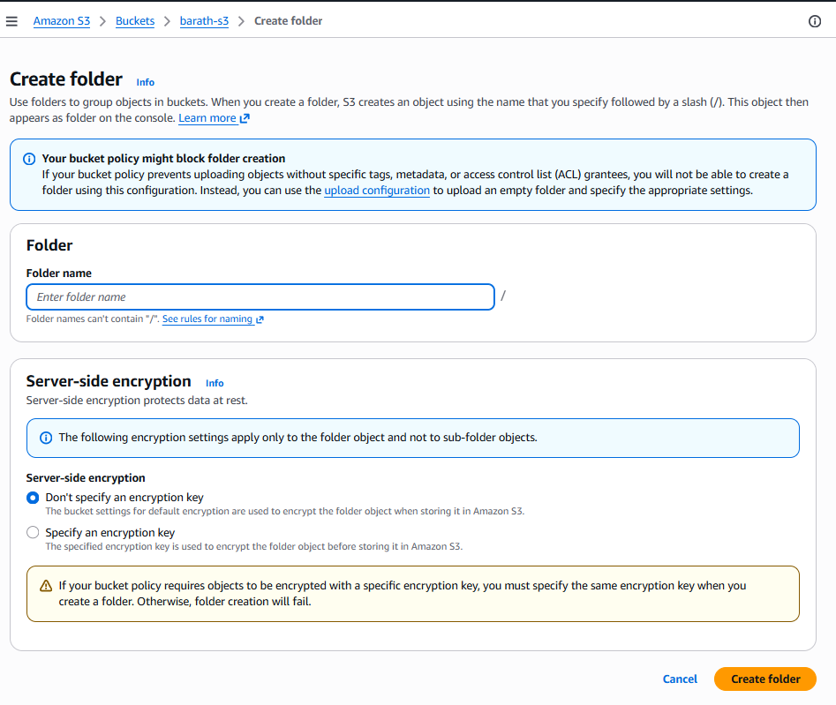
Again
images/
Again
backups/
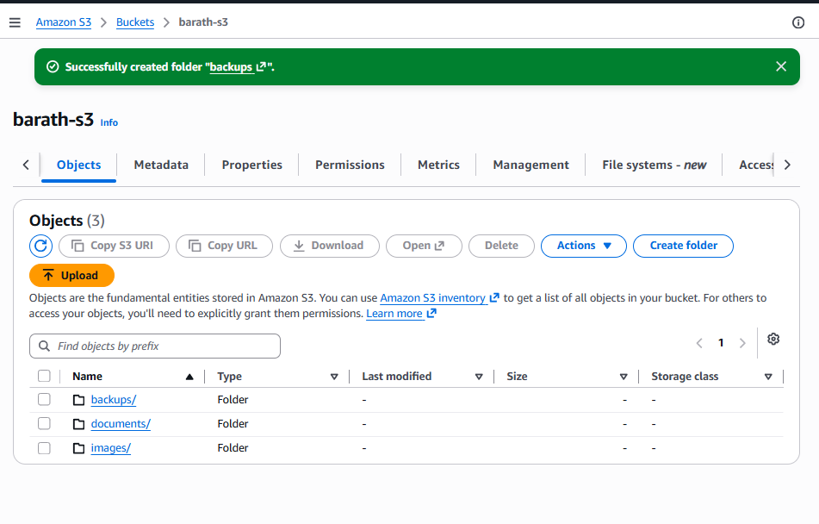

Validation
Bucket should contain
documents/

images/

backups/

Exercise 3 - Upload Files
Upload
hello.txt

sample.pdf

photo.jpg
Upload
hello.txt
inside
documents/
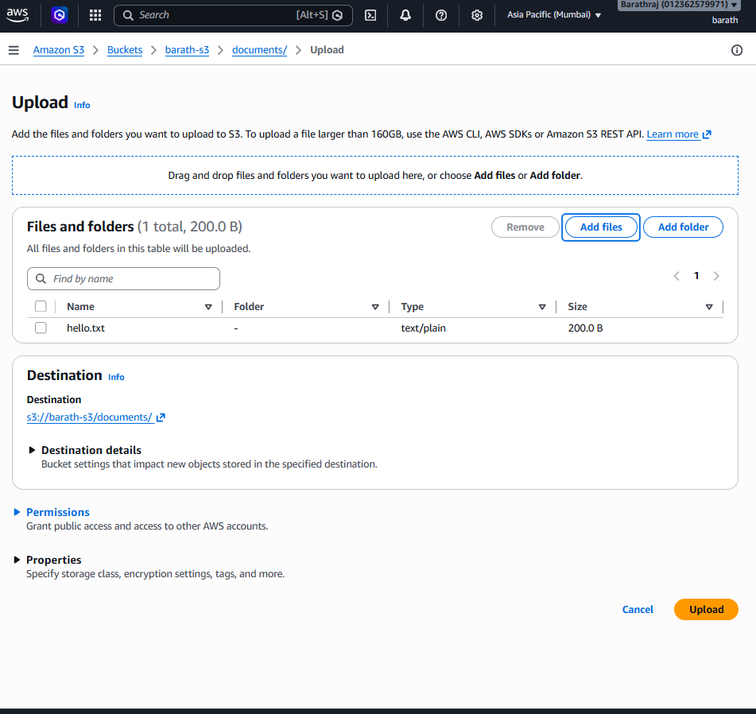
Upload
photo.jpg
inside
images/
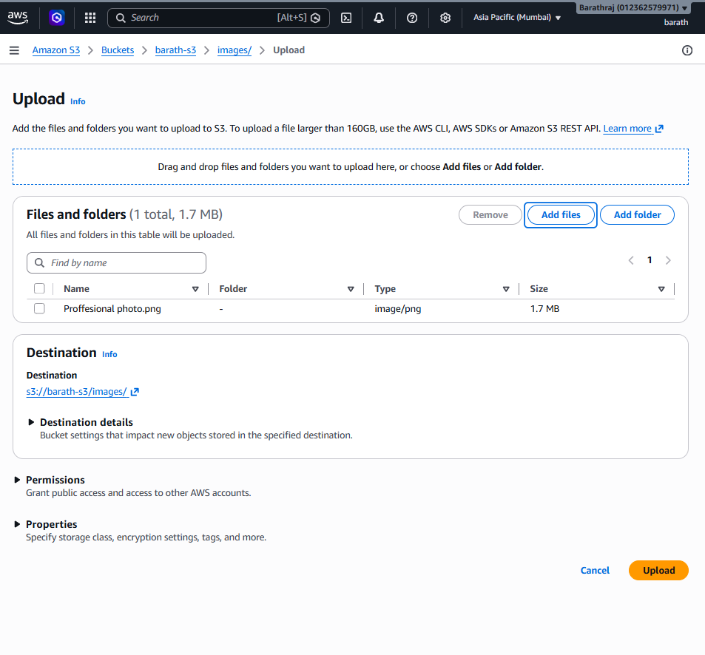

Validation
Verify
documents/
hello.txt
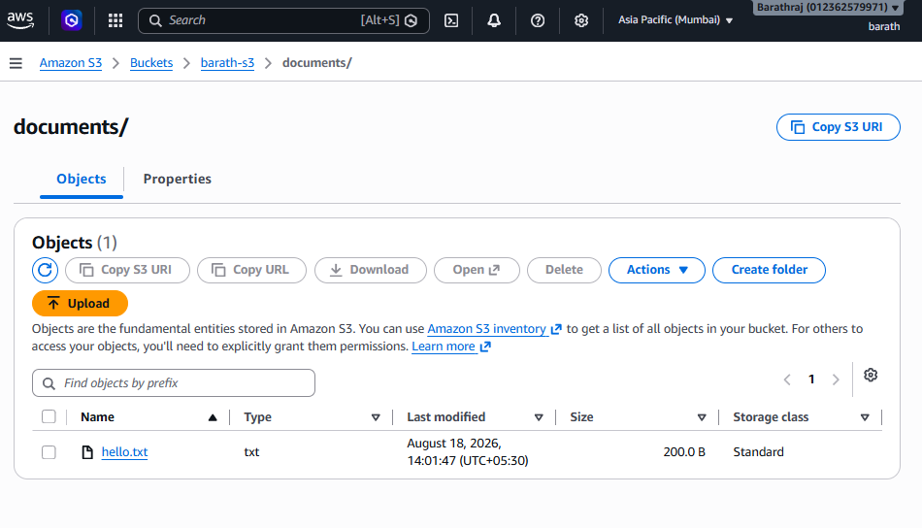

images/
photo.jpg
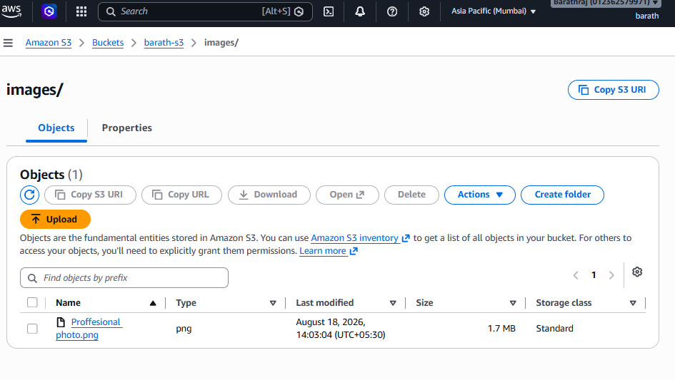

Exercise 4 - Enable Versioning
Open
Bucket
Go to
Properties
Find
Bucket Versioning
Click
Edit
Choose
Enable
Save.
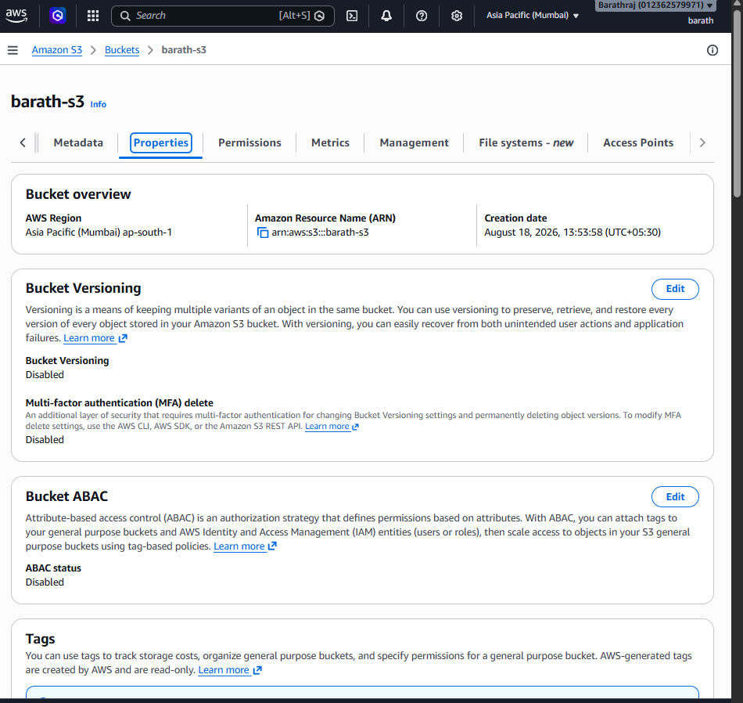
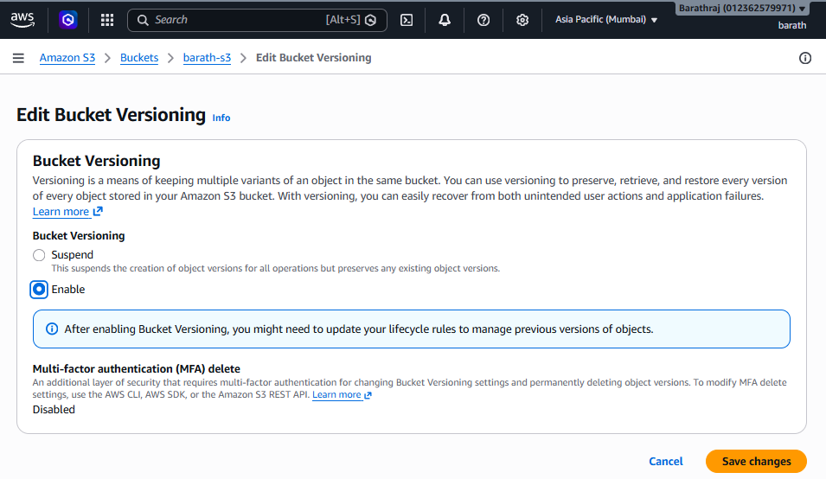

Validation
Properties should display
Bucket Versioning

Enabled
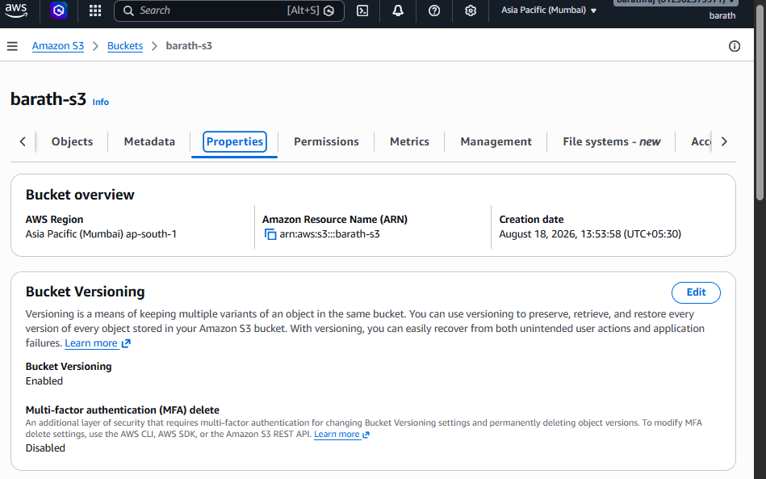

Exercise 5 - Upload New Version
Open
documents/
Edit
hello.txt
Original
Hello AWS
Change to
Hello AWS Version 2
Save locally.
Upload again.
Select
Replace existing object
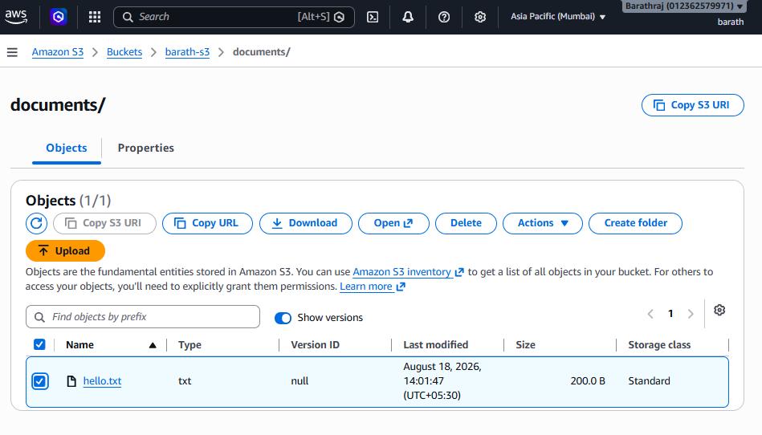
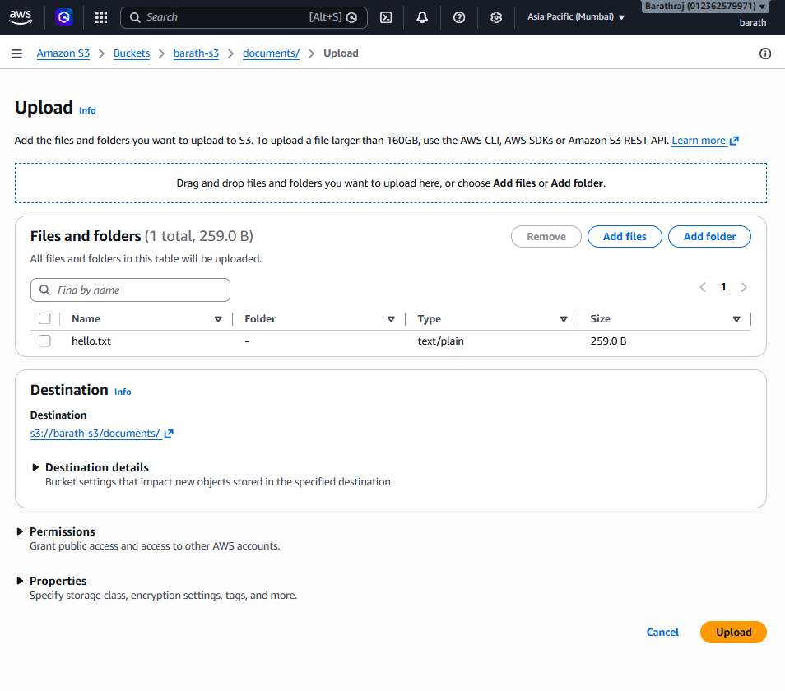

Validation
Object still appears
hello.txt
Only one file is visible.
But internally
Version 1

Version 2
exist.
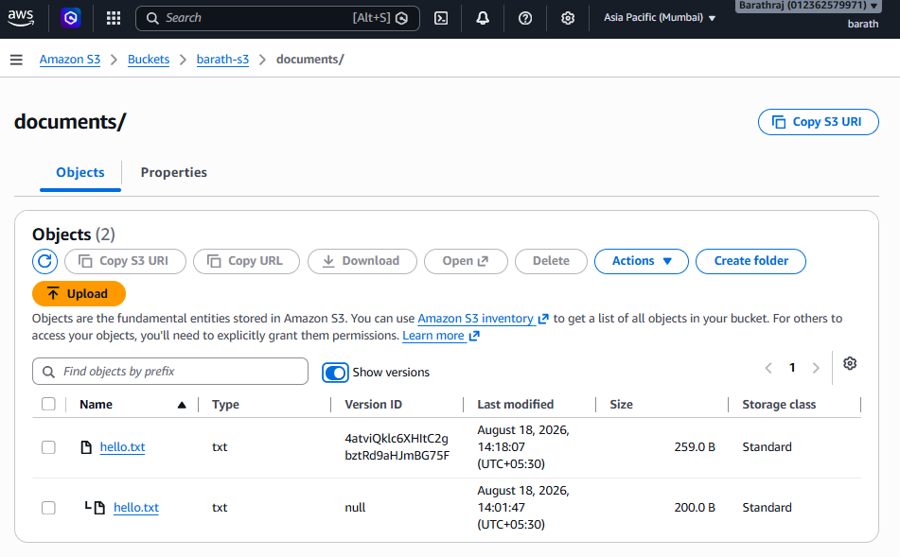

Exercise 6 - Verify Versions
Click
Show versions
You should see
hello.txt

Version ID:
3HL4K...

Latest

------------

hello.txt

Version ID:
9KKHJ...

Validation
There should be multiple versions.

Exercise 7 - Delete Object
Delete
hello.txt
Confirm deletion.
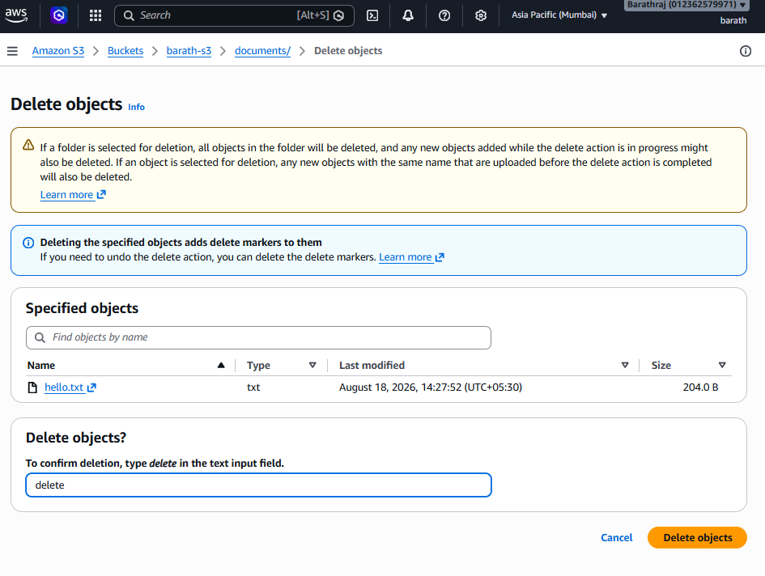

Validation
Without
Show Versions
File disappears.
With
Show Versions
You should see
Delete Marker

Version 2

Version 1
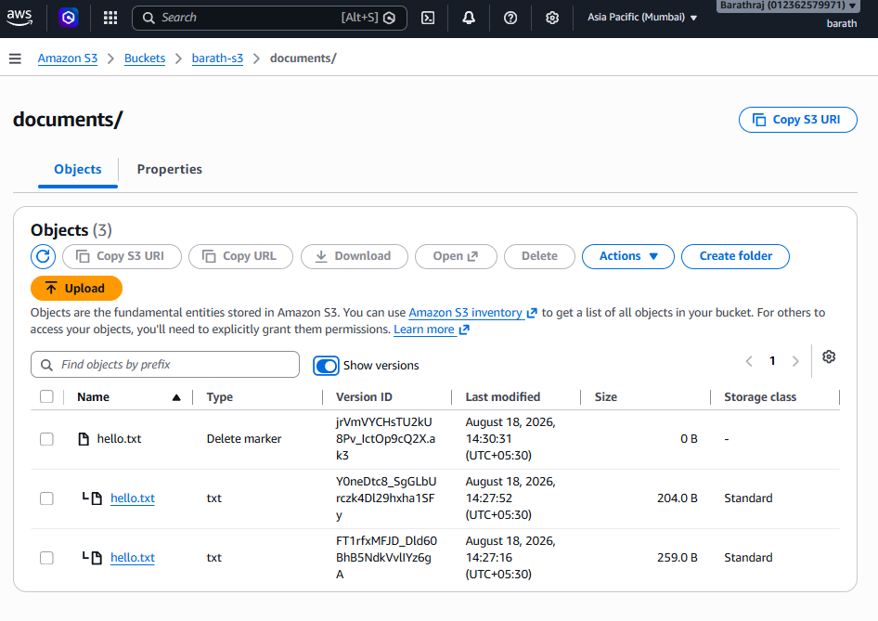

Exercise 8 - Restore Deleted Object
Enable
Show Versions
Locate
Delete Marker
Delete ONLY
Delete Marker
NOT
Version 1

Version 2
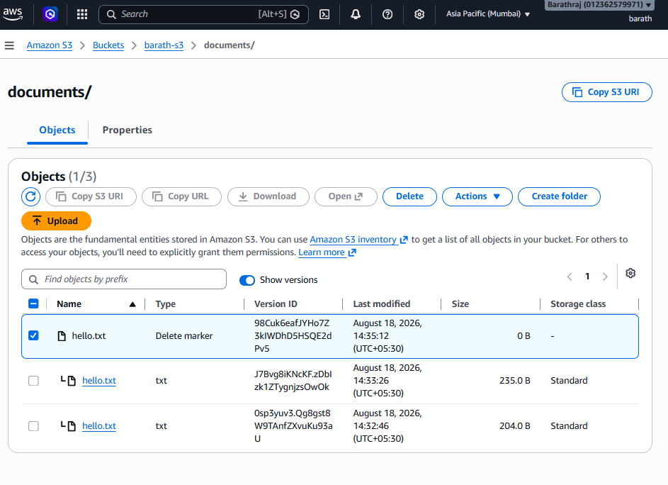
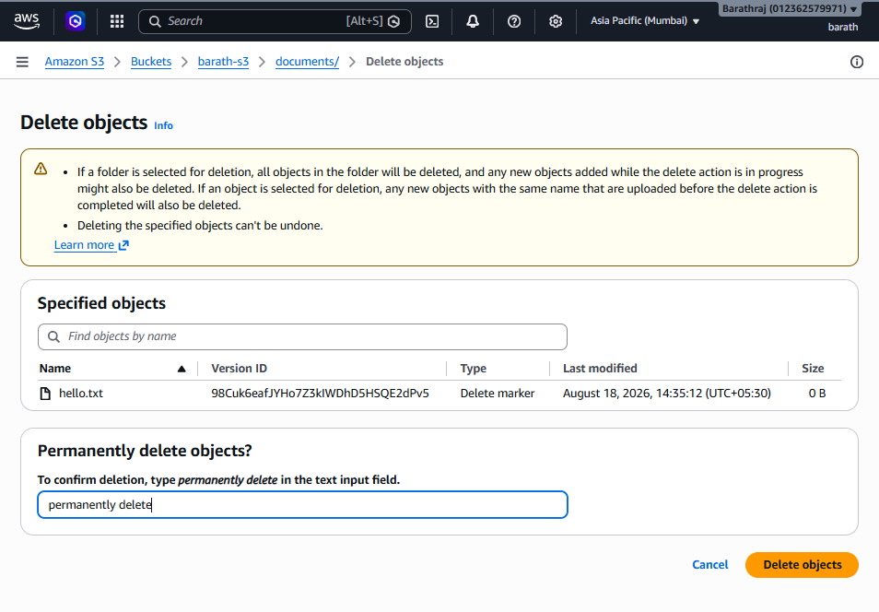

Validation
Latest version becomes visible again.
hello.txt
opens successfully.
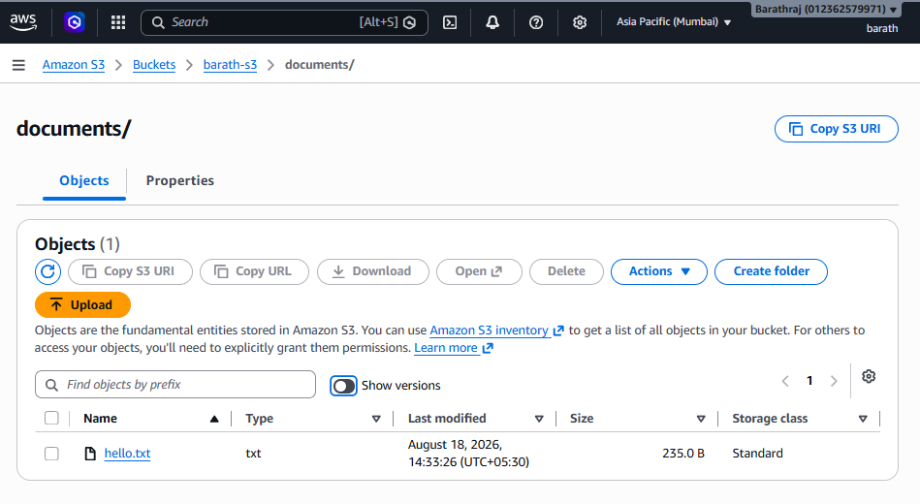

Exercise 9 - Enable ACLs
By default
ACL Disabled
Create a new bucket (or delete and recreate the bucket), because Object Ownership cannot be changed after bucket creation.
During bucket creation:
Object Ownership
Select:
ACLs enabled
Choose:
Bucket owner preferred
For Block Public Access, uncheck all options if you plan to test public access.
Acknowledge the warning and create the bucket.
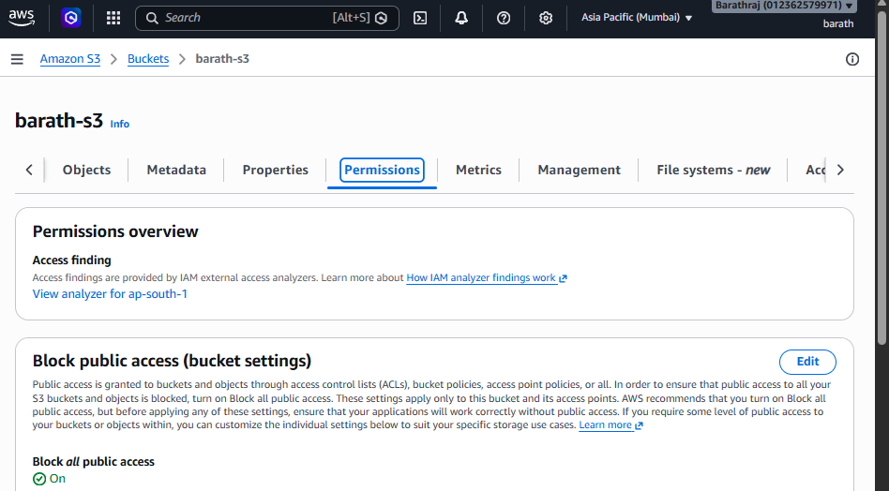
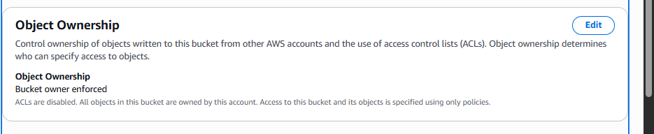
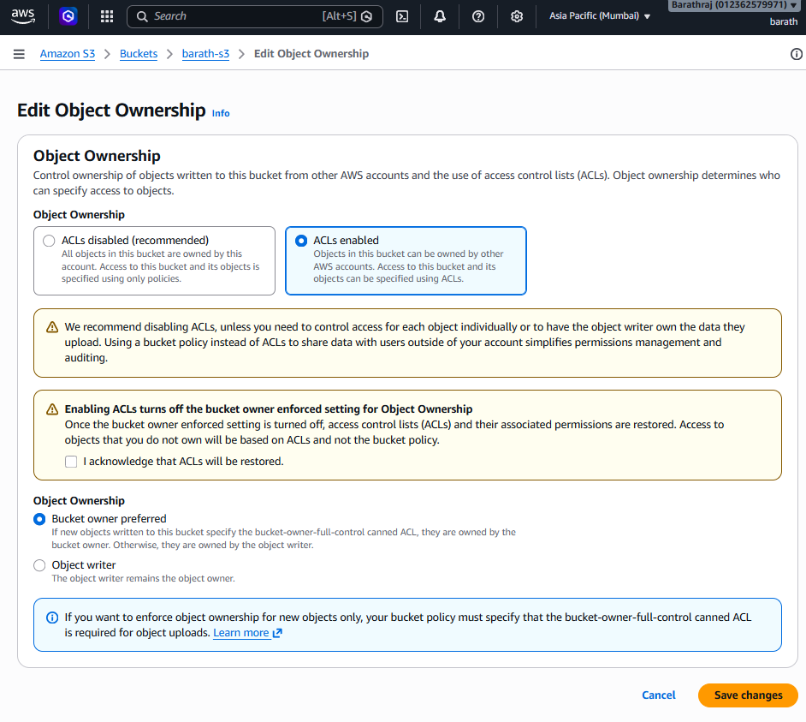
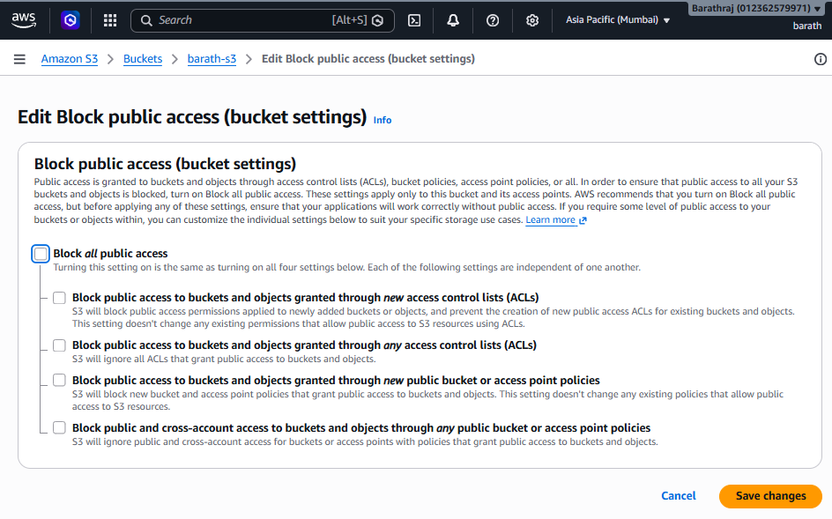

Validation
Open:
Permissions
You should see
Object Ownership

ACLs Enabled
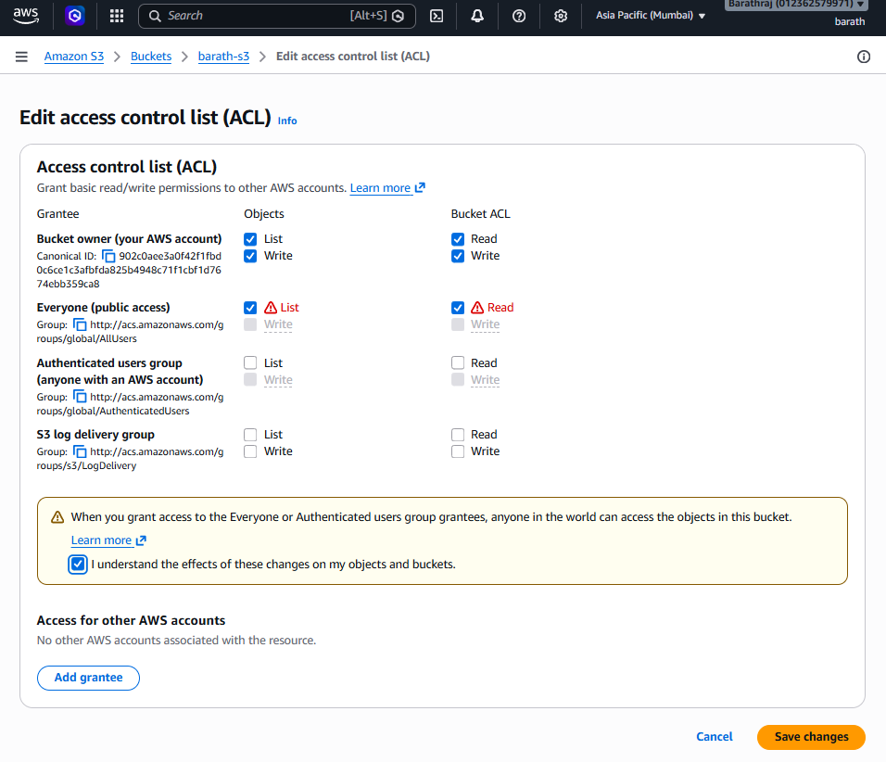
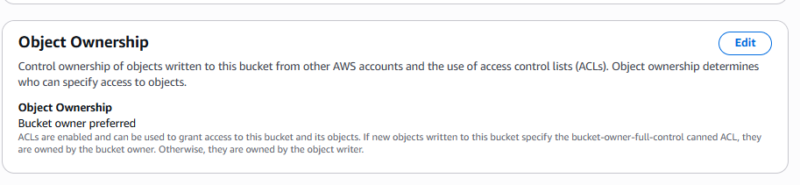

Exercise 10 - Make Object Public Using ACL
Upload
hello.txt
Select the object.
Choose
Actions

Edit ACL
Grant
Everyone (public access)

Read
Save.
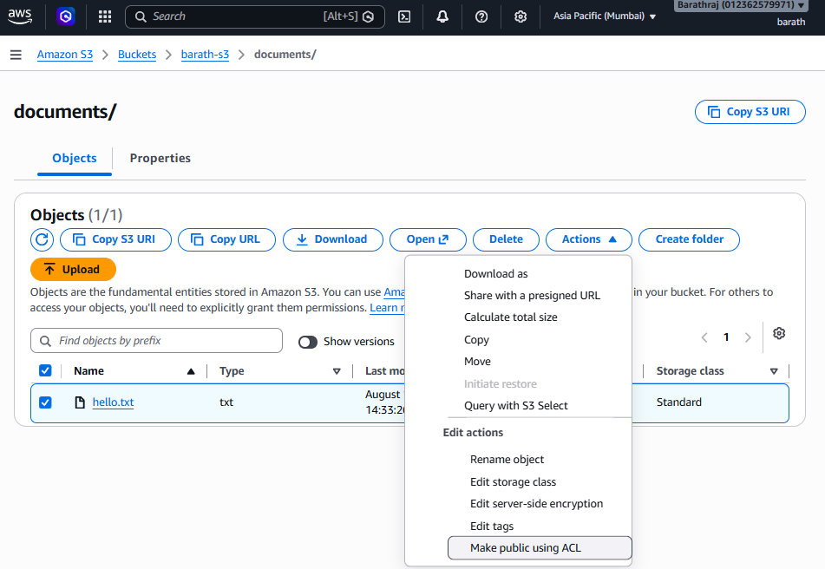
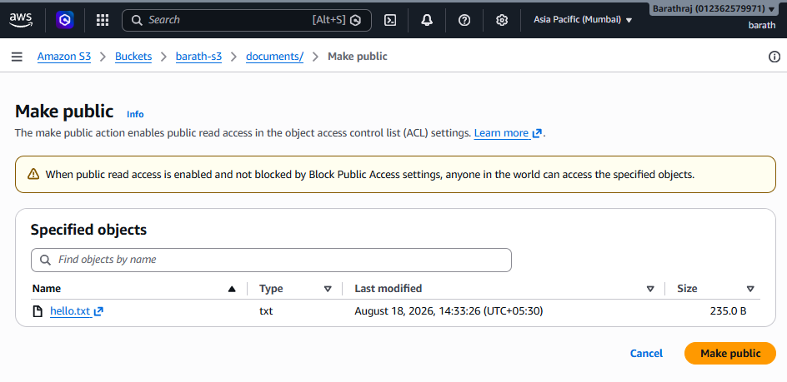

Validation
Object shows
Publicly Accessible

Exercise 11 - Access Object Using URL
Open object.
Copy
Object URL
Example
https://balaji-s3-lab-002.s3.ap-south-1.amazonaws.com/hello.txt
Open browser.
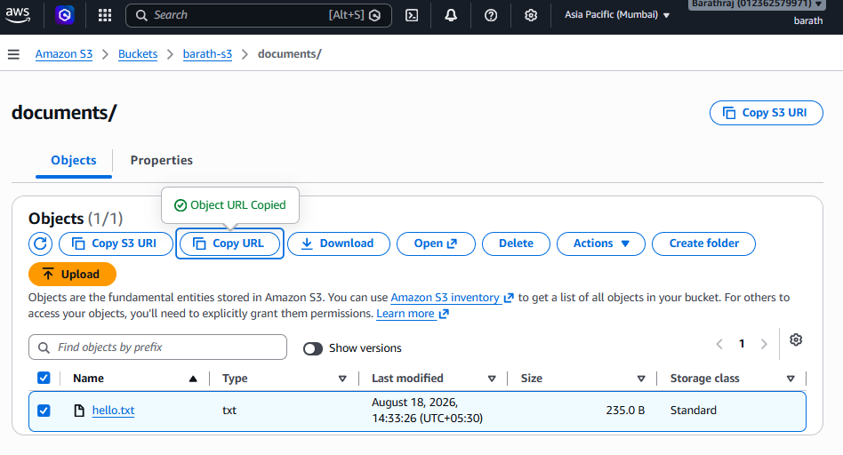
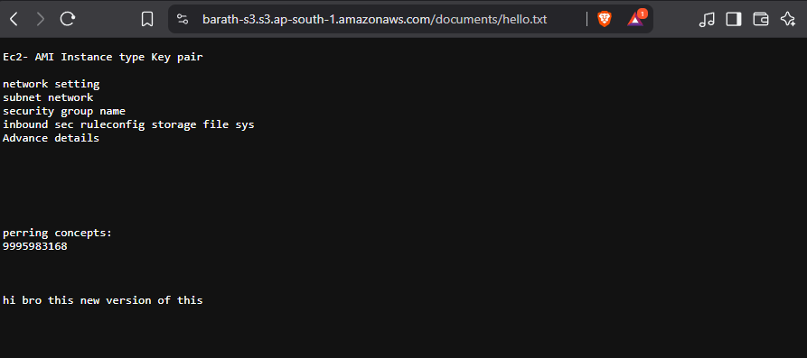

Validation
Expected output
Hello AWS
No authentication required.

Exercise 12 - Disable ACL (Recommended)
For a new bucket:
Create another bucket with:
ACLs Disabled
(Default configuration)
Upload
hello.txt
Notice there is no option to edit object ACLs.
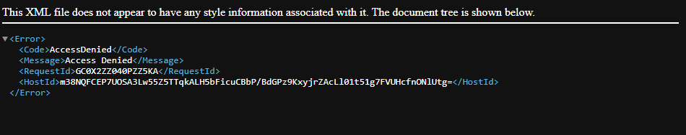

Validation
Attempt to use the object URL.
Expected:
AccessDenied

Exercise 13 - Make Object Public Using Bucket Policy
Open:
Permissions
Select:
Bucket Policy
Paste the following policy (replace YOUR-BUCKET-NAME):
{
"Version": "2012-10-17",
"Statement": [
{
"Sid": "PublicReadObjects",
"Effect": "Allow",
"Principal": "*",
"Action": "s3:GetObject",
"Resource": "arn:aws:s3:::YOUR-BUCKET-NAME/*"
}
]
}
Save the policy.
If Block Public Access is still enabled, AWS will prevent you from saving or the policy will not take effect. Disable the bucket-level Block all public access setting first.
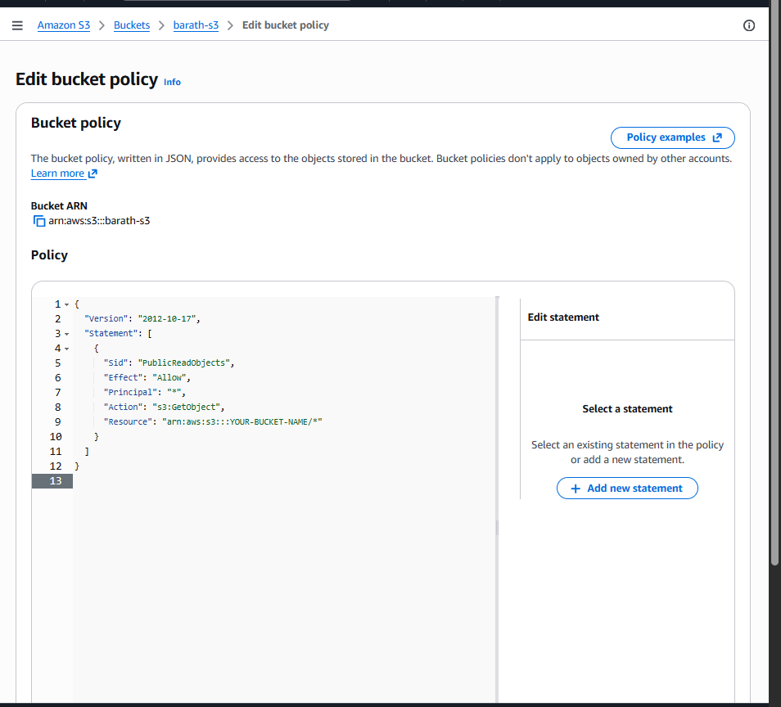
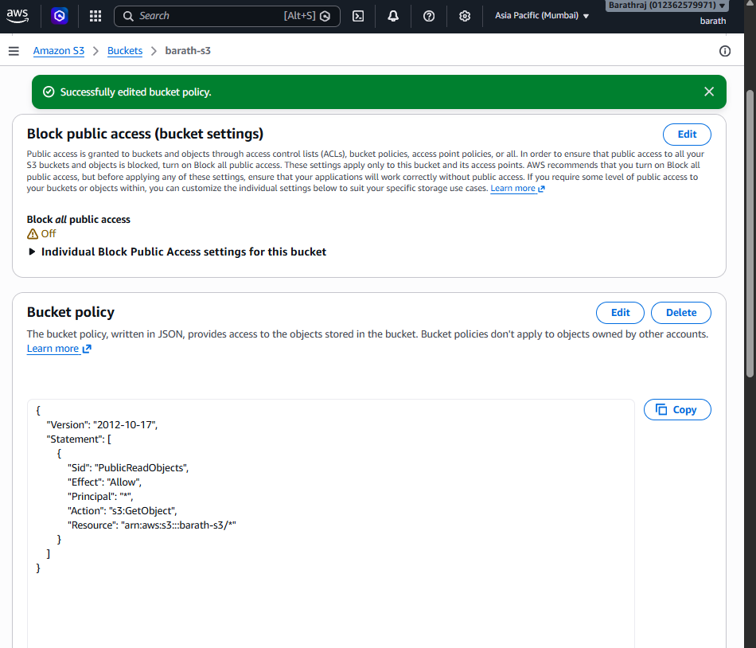
In the coding give the bucket name in the last.

Validation
Open
Object URL
Browser displays
Hello AWS
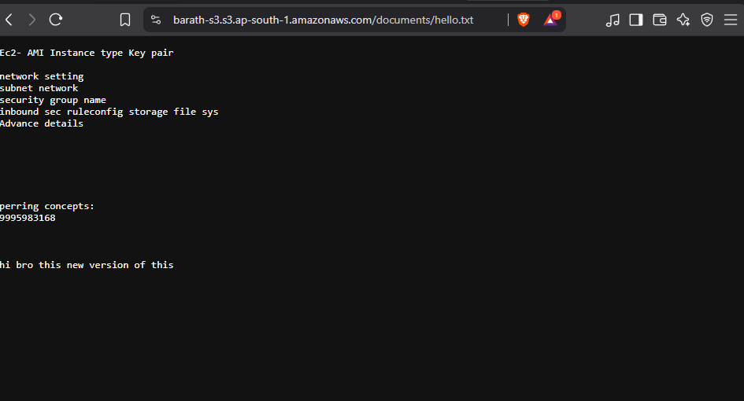

Exercise 14 - Block Public Access
Open
Permissions
Select
Block Public Access
Enable
✔ Block all public access
Save changes.
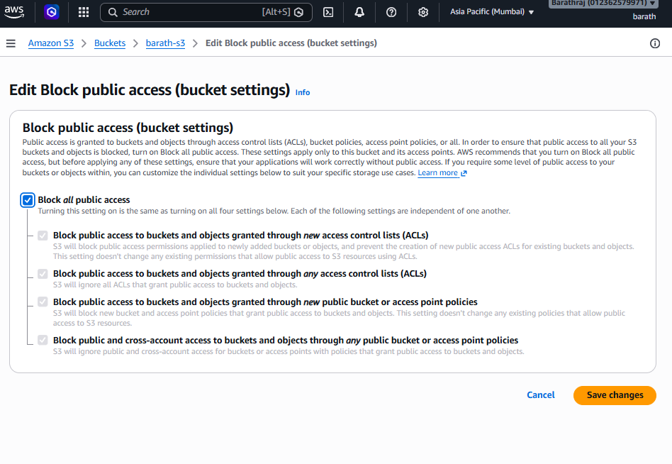

Validation
Open
Object URL
Expected
<Error>
<Code>AccessDenied</Code>
<Message>Access Denied</Message>
</Error>
The bucket policy still exists, but Block Public Access overrides public access.
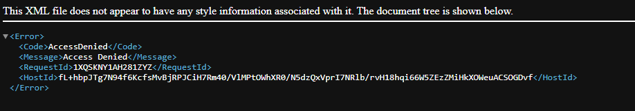

Final Validation Checklist
Task | Expected Result
Create bucket | ✅ Bucket created
Create folders | ✅ documents/, images/, backups/
Upload files | ✅ Files visible
Enable versioning | ✅ Status shows Enabled
Upload new version | ✅ Multiple versions exist
Show versions | ✅ Version IDs displayed
Delete object | ✅ Delete marker created
Restore object | ✅ Delete marker removed, object visible again
Create bucket with ACLs enabled | ✅ Object Ownership = ACLs enabled
Make object public using ACL | ✅ Public object accessible by URL
Access object from browser | ✅ File contents displayed
Create bucket with ACLs disabled | ✅ No ACL editing option
Add bucket policy | ✅ Public access via policy works
Enable Block Public Access | ✅ Public access denied
Validate Access Denied | ✅ Browser returns AccessDenied

Key Concepts Learned
Feature | Purpose
Bucket | Stores objects in S3
Folder (Prefix) | Organizes objects logically
Versioning | Protects against accidental overwrite or deletion
Delete Marker | Marks an object as deleted without removing previous versions
ACL | Legacy mechanism for object-level permissions
Bucket Policy | Recommended way to grant bucket/object access
Block Public Access | Prevents accidental public exposure of data
Object URL | Direct HTTPS URL to an object (accessible only if permissions allow)
This lab takes approximately 60–90 minutes to complete and covers the most common S3 administration tasks expected in AWS hands-on practice and certification labs.

